SBIR/STTR Reauthorization  What You Need to Know  Small Business Innovation and Economic Security Act | April 2026 | 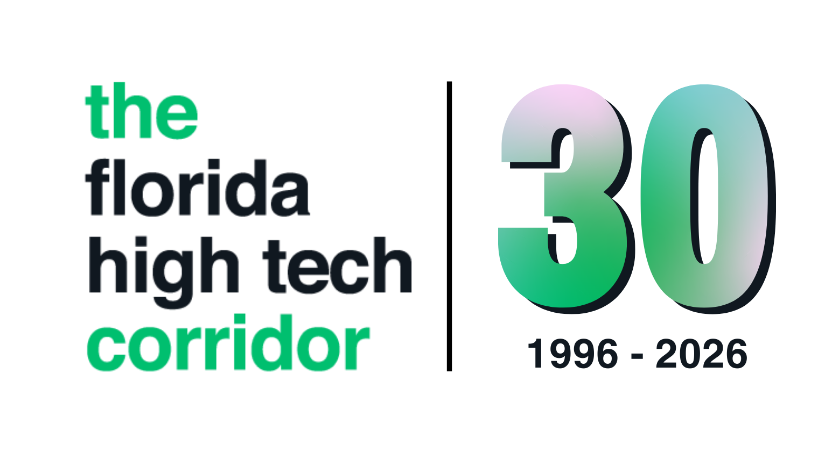

After expiring on September 30, 2025, the SBIR/STTR program is now reauthorized under the Small Business Innovation and Economic Security Act. This is strongly positive news for small businesses developing new research & development - the core program is intact and several meaningful improvements have been made.

⏰ | Agencies may release solicitations quickly after enactment to obligate funds. FY26 underspend may also roll into FY27, potentially making it one of the most active solicitation cycles in years. Start planning your proposals now - don't wait for solicitations to drop to think about your scope of work. Keep an eye out for frequent solicitation releases once the program is reauthorized.

The Program at a Glance
What's Changing | What's Staying the Same
Program authorized through September 30, 2031 | SBIR set-aside: 3.2% of agency extramural R&D
New Strategic Breakthrough Phase II (up to $30M per award) | STTR set-aside: 0.45% of agency extramural R&D
TABA funds expanded and more flexible | Core small business eligibility rules
New foreign risk due diligence requirements | Phase I, Phase II, Phase III structure
Proposal submission caps per agency | No $75M lifetime cap - that proposal was dropped
FY26 carryover funds roll into FY27 | STTR 40% small business & 30% research institution workshare rules preserved

1. Program Extended Through 2031
The reauthorization runs for five years - through September 30, 2031. This is not a permanent authorization; Congress will need to act again before that date. However, for companies currently working Phase I contracts or planning future submissions, this provides meaningful runway and funding stability. The program's structure - phases, set-asides, and eligibility - is unchanged by this reauthorization. It extends the existing framework, not redesigns it.

2. Key Structural Changes You Should Know

New Strategic Breakthrough Phase II
The most significant new opportunity in the bill. A new category of expanded Phase II awards is designed to bridge the gap between R&D and commercialization. Key features:
- Awards up to $30M (agency-dependent), with grant terms up to 4 years
- A 1:1 match of non-SBIR funds is required for every dollar awarded
- Matching sources can include venture capital, non-SBIR federal funds through grants or contracts
- Implementation and availability may vary widely between agencies. DoD, NIH, NASA, and NSF are excepted to be active early with Strategic Breakthrough Phase II opportunities - companies in defense tech, life sciences, and deep tech should pay closest attention

TABA: Expanded Commercialization Funding
Technical and Business Assistance (TABA) funding - a separate budget category within the core R&D award that funds non-research activities - has been expanded and solidified as common practice across agencies. Every Phase I and Phase II company should consider including TABA in their proposal budget. New authorizations include:
- Using TABA to fund your own staff time on commercialization activities and training (not just outside consultants). Companies will need to monitor how this defined across agencies
- Cybersecurity compliance assistance (CMMC, NIST SP 800-171)
- Foreign involvement screening and cap table review
- Freedom to choose your own TABA vendors – agencies need to be more flexible allowing company-selected vendors
TABA ceilings are now uniform by statute: $6,500 at Phase I and $50,000 at Phase II.

Foreign Risk & Due Diligence
Agencies now have expanded authority to review foreign influence and ownership as part of the SBIR/STTR application process. This includes ownership structure, investor relationships, key personnel affiliations, and cybersecurity practices. Transparency and proactive disclosure are critical - gaps discovered later are far more problematic than upfront disclosure.

Proposal Submission Caps
Agencies are now required to establish limits on how many proposals a single company can submit. This signals a clear shift toward quality over quantity:
- Every agency has flexibility to apply this differently – either as a limit on proposals per topic, per solicitation or per year. Pay attention to how each agencies implements this change.
- Be selective and strategic about topic choices
- Agencies are screening harder - proposals without genuine technical differentiation will fare poorly
- Waivers are allowed for urgent national security topics but capped at 5% of topics

3. FY27 May Be an Unusually Active Year
Because reauthorization happened mid-fiscal year (FY26), many agencies will have limited time to fully obligate their SBIR funds. The new bill includes a carryover provision: under-obligated FY26 funds can roll into FY27.
Combined with the regular FY27 SBIR set-aside, this could result in a larger-than-normal number of solicitations - more Phase I and Phase II opportunities at a faster pace.
📅 | The window to prepare is now. Companies that have proposals ready when solicitations drop in FY27 will have a meaningful competitive advantage. This is particularly true for larger grant-focused agencies like NSF and NIH as well as DOD.

4. What Was Debated But Dropped
Several provisions did NOT make it into the final bill:

Provision Debated | Final Outcome
$75M lifetime award cap | Not adopted - no cap on cumulative awards
Permanent authorization | Extended through 2031 only (not permanent)
Set-aside rate modifications | SBIR 3.2% / STTR 0.45% unchanged
Stricter commercialization thresholds for repeat awardees | Not adopted - core eligibility rules unchanged
Stronger exclusions for high-volume firms | Replaced with targeted proposal caps only
Tighter STTR performer rules | STTR pathway and workshare requirements preserved

5. Bottom Line for Your Company
- The program is intact through 2031
- Start proposal preparation now, before solicitations are released - FY27 may see elevated activity
- Consider TABA in every proposal budget – these allow you to spend SBIR/STTR funding on traditionally non-research activities normally restricted
- If you're a Phase II winner, begin exploring the Strategic Breakthrough opportunity as agencies implement it
- Review your cap table, investor relationships, and key personnel affiliations ahead of your next submission
- Focus on proposal quality and topic specificity - volume-based strategies are becoming less effective

FL FAST | Florida High Tech Corridor | floridahightech.com  This document is a summary for informational purposes and should not be construed as legal or procurement advice. | April 2026

